Name: Kanak Agrawal

Email: [Kanakagrawal2001@gmail.com](mailto:Kanakagrawal2001@gmail.com)

Date: 23-02-2024

Assignment Day- 24(Azure Devops)

**Creating a folder on local downloads**

**Git bash Command**

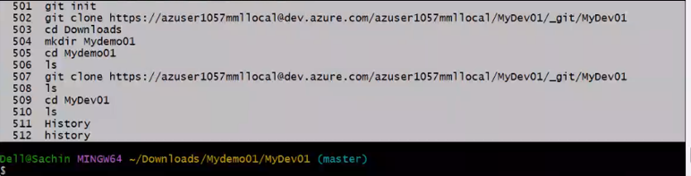

**Azure Devops**

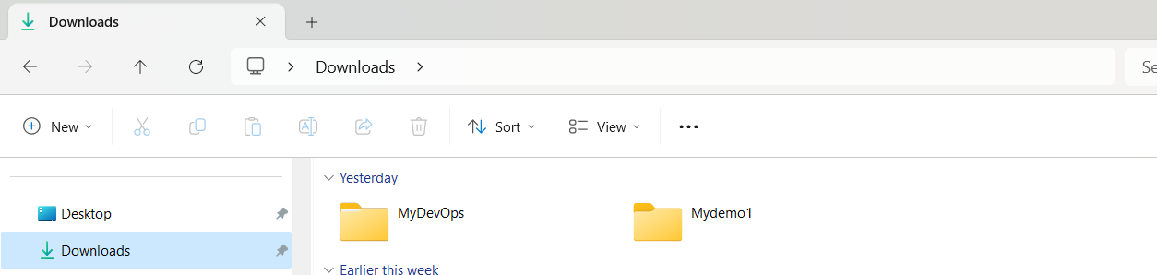

**Uploading a file and committing it and pushing it**

**Git bash command**

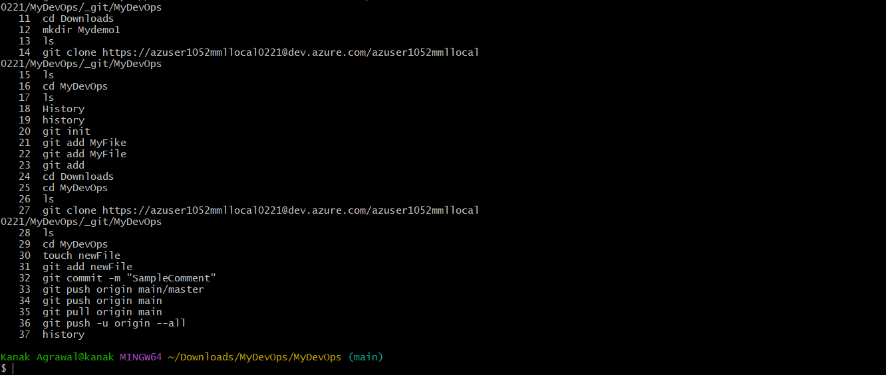

**Azure Devops**

